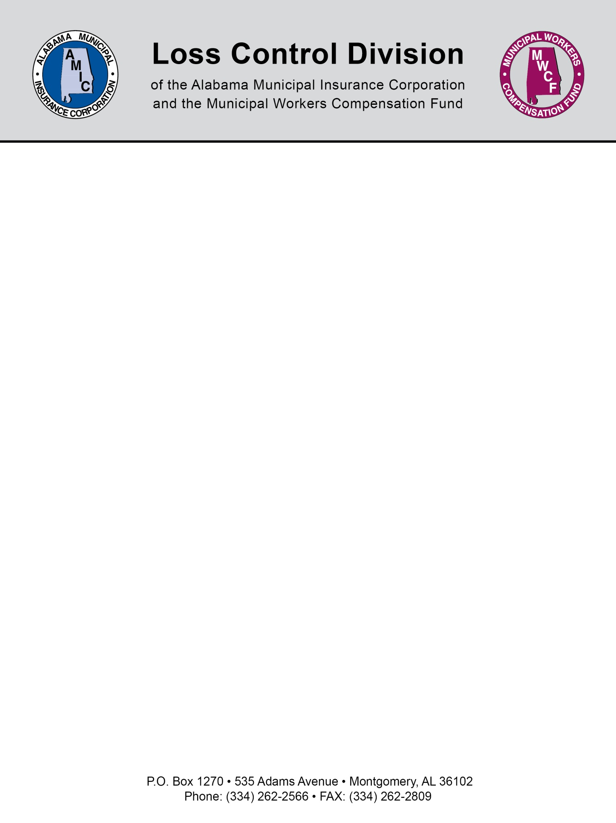

Sample Fleet Safety Program

Section One: General Policy

The goal of the City of Blank is to do everything reasonable to prevent injury and/or property damage as a result of auto accidents involving employees, visitors and/or residents of the City. The City recognizes that the safety and well being of all City personnel is important for both humanitarian and economic reasons.

The City maintains a fleet of “motor vehicles” (defined for this Program as being any motorized vehicle requiring registration with the State of Alabama), for the express use of City officials and employees to conduct official City business. This Fleet Safety Program provides policy and protocol governing the use of motor vehicles within the City owned and operated fleet.

Violation of this policy may subject employees to administrative action, up to and including formal disciplinary action resulting in termination of their employment.

Every City employee who is required to hold a Commercial Driver's License (CDL) and who operates a motor vehicle designed to transport 16 or more passengers (including the driver), or with a weight of 26,000 or more pounds, or is used to transport hazardous materials which require the motor vehicle to be placarded, is required to submit to the following drug and alcohol tests:
- Pre-employment (including those currently employed who are assigned safety-sensitive functions for the first time);
- Random;
- Post-accident;
- Reasonable Suspicion;
- Return to Duty; and/or
- Follow-up

Section Two: Driver Qualification and Eligibility Standards

- Driver Qualifications:

A City employee may drive a City vehicle as part of his or her employment if he or she:

- is at least twenty-one (21) years old and has three (3) years of driving experience; and
- has a valid license that is not a conditional license or a restricted use license; and
- has had his or her motor vehicle record reviewed by the Director of Risk and Safety per the terms and conditions of this program prior to being hired; and
- has no restrictions that would prevent the employee from legally or safely operating a City vehicle assigned to him or her for work assignments.

- Eligibility to Drive a City Vehicle:

A City employee shall no longer be eligible to drive a City vehicle as part of his or her employment if he or she:

- has Alabama Driver’s license that is no longer a valid license, or is a conditional license, or is a restricted use license; or
- has any restrictions that would prevent the employee from legally or safely operating a motor vehicle assigned to him or her for work assignments; or
- has three (3) at fault accidents within a period of two (2) years; or
- fails a drug test administered by the City pursuant to his or her employment.

- Repeat Offenses:

In the event an employee loses his or her eligibility to drive a City vehicle twice during any three (3) year period, the employee shall lose his or her eligibility to drive a City vehicle for a period of two (2) years from the date of the last loss of eligibility. The employee’s eligibility to drive a City vehicle may be reinstated after the two year period only upon recommendation of the Safety Committee and approval of the City Council.

Section Four: Motor Vehicle Use Policy

All drivers of City vehicles must observe Alabama State Vehicle and Traffic Laws and City’s Fleet Safety Programming including but not limited to:

- Wearing seat belts per Alabama State Vehicle and Traffic Laws;
- Observing the City’s Smoking Policy prohibiting any smoking when operating City equipment and vehicles;
- Refraining from using a cell phone for talking or texting;
- Refraining from using alcoholic beverages or drugs while operating City vehicles or equipment per the City’s Substance Abuse Policy;
- Operating a City vehicle or equipment for the sole purpose of City business;
- Allowing only City employees as passengers with the exception of the transport of individuals as it pertains to law enforcement and emergency medical services;
- Being personally responsible for any ticket issued by a law enforcement official as a result of a violation of the Alabama State Vehicle and Traffic Laws while driving a City vehicle;
- Notifying the Director of Risk and Safety of the use of City:
  - law enforcement vehicles for authorized law enforcement activities outside of a one hundred (100) mile radius from City limits;
  - fire and emergency management vehicles for authorized City business use outside of a fifty (50) mile radius from City limits; and
  - all other City vehicles for authorized City business use outside of the City limits.
- At no time, EXCEPT for law enforcement in the performance of their official duties, have any weapon of any kind within his/her personal vehicle and/or a City motor vehicle while on City owned, leased or maintained property or in the course of his/her employment. An employee who is identified as having a weapon of any kind in violation of this policy shall be immediately reported to the police for investigation.)

Section Five: Vehicle Maintenance and Safety

All drivers shall be required to adhere to their departmental vehicle maintenance and safety inspection guidelines. The City’s mechanics or designated repair shops shall be responsible for the performance of routine maintenance (other than warranty items) and repair of all City motor vehicles and equipment including but not limited to:

- Employees are required to conduct a vehicle maintenance and safety inspection for their assigned vehicle prior to and at the end of their use of the City vehicle and immediately report any known or suspected mechanical and physical defects to their supervisor.
- Supervisors shall be responsible for enforcing the City’s Fleet Safety Vehicle Maintenance and Safety Standards for the employees assigned to their work group.
- Each City department shall be responsible for the documentation of scheduled and unscheduled maintenance on each City owned vehicle within its control. This documentation shall be available for review by the Director of Risk and Safety as needed in support of the City’s Risk and Safety Program.
- Each department shall be responsible for the establishment of a written scheduled (planned) preventive maintenance program for scheduling and maintaining records of service on each City vehicle.

Section Six: Accident Reporting

Motor vehicle accidents are defined as any occurrence involving the operation of a City owned or leased motor vehicle, being operated by a City employee while engaged in the performance of his/her duties that result in death, physical injury or property damage.

The following Rules of the Road apply to any accident involving a City employee and the motor vehicle he/she is assigned to:

- Any accident involving a City motor vehicle must be IMMEDIATELY reported to the City Police Department.
- The City’s Police Department shall investigate all City accidents and provide completed accident reports to the Director of Risk and Safety.
- Accidents are to be reported immediately to the employee’s supervisor, department head and the Director of Risk and Safety within twenty-four (24) hours of their occurrence. The City’s Employee Incident Report shall be completed and transmitted to the Director of Risk and Safety after review by the applicable department head.

NOTE: This document is not intended to be legal advice. It does not identify all the issues surrounding the particular topic. Public agencies are encouraged to review their procedures with an expert or an attorney who is knowledgeable about the topic. Reliance on this information is at the sole risk of the user.

Revised 5/2015

